**ASSIGNMENT 4**

|  |  |
| --- | --- |
| Assignment Date | 06 November 2022 |
| Student Name | Ms.P.Aswini |
| Student Roll Number | 715319106004 |
| Maximum Marks | 2 Marks |

**Applications of AI in Banking**

The three main channels where banks can use artificial intelligence to save on costs are front office (conversational banking), middle office (anti-fraud) and back office (underwriting).

In this report, Business Insider Intelligence identifies the most meaningful AI applications across banks' front and middle offices. We also discuss the winning AI strategies used by financial institutions so far, and provide recommendations for how banks can best approach an AI-enabled digital transformation.

* Front- and middle-office AI applications offer the greatest cost savings opportunity across banks.
* Banks are leveraging AI on the front end to smooth customer identification and authentication, mimic live employees through chatbots and voice assistants, deepen customer relationships, and provide personalized insights and recommendations.
* AI is also being implemented by banks within middle-office functions to detect and prevent payments fraud and to improve processes for anti-money laundering (AML) and know-your-customer (KYC) regulatory checks.
* The winning strategies employed by banks that are undergoing an AI-enabled transformation reveal how to best capture the opportunity. These strategies highlight the need for a holistic AI strategy that extends across banks' business lines, usable data, partnerships with external partners, and qualified employees.

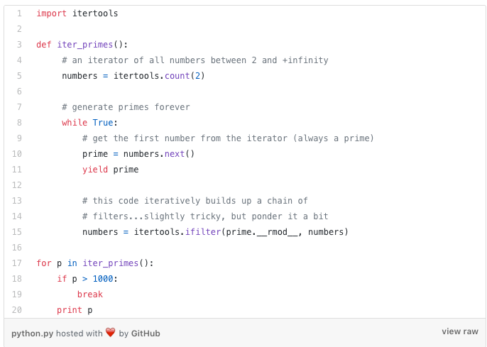

### ****Cybersecurity and fraud detection****

Every day, huge number of digital transactions take place as users pay bills, withdraw money, deposit checks, and do a lot more via apps or online accounts. Thus, there is an increasing need for the banking sector to ramp up its cybersecurity and fraud detection efforts.

This is when artificial intelligence in banking comes to play. AI can help banks improve the security of online finance, track the loopholes in their systems, and minimize risks. AI along with [machine learning can easily identify fraudulent activities](https://appinventiv.com/blog/role-of-machine-learning-in-financial-fraud-detection/) and alert customers as well as banks.

For instance, Danske Bank, Denmark’s largest bank, implemented a fraud detection algorithm to replace its old rules-based fraud detection system. This deep learning tool increased the bank’s fraud detection capability by 50% and reduced false positives by 60%. The system also automated a lot of crucial decisions while routing some cases to human analysts for further inspection.

AI can also help banks to manage cyber threats. In 2019, the financial sector accounted for [29% of all cyber attacks](https://richeymay.com/resource/articles/state-of-cybersecurity-2020/), making it the most-targeted industry. With the continuous monitoring capabilities of artificial intelligence in financial services, banks can respond to potential cyberattacks before they affect employees, customers, or internal systems.

## ****How to become an AI-first bank?****

Now that we have seen[how AI is used in banking](https://appinventiv.com/blog/artificial-intelligence-revamping-user-experience-in-mobile-banking-apps/), in this section, we will look into the steps that banks can take to adopt AI on a broad scale and evolve their processes while paying due attention to the four critical factors — people, governance, process, and technology.

### ****Step 1: Develop an AI strategy****

The [AI implementation process](https://appinventiv.com/blog/how-to-integrate-machine-learning-artificial-intelligence-into-apps/) starts with developing an enterprise-level AI strategy, keeping in mind the goals and values of the organization.

It’s crucial to conduct internal market research to find gaps among the people and processes that AI technology can fill. Make sure that AI strategy complies with the industry standards and regulations. Banks can also evaluate the current international industry standards.

The final step in AI strategy formulation is to refine the internal practices and policies related to talent, data, infrastructure, and algorithms to provide clear directions and guidance for adopting AI across the bank’s various functional units.

### ****Step 2: Plan a use case-driven process****

The next step involves identifying the highest-value AI opportunities, aligning with the bank’s processes and strategies.

Banks must also evaluate the extent to which they need to implement AI banking solutions within their current or modified operational processes.

After identifying the potential AI and machine learning use cases in banking, the technology teams should run checks for testing feasibility. They must look into all aspects and identify the gaps for implementation. Based on their evaluation, they must select the most feasible cases.

The last step in the planning stage is to map out the AI talent. Banks require a number of experts, algorithm programmers, or data scientists to develop and implement AI solutions. If they lack in-house experts, they can outsource or collaborate with a technology provider.

### ****Step 3: Develop and deploy****

After planning, the next step for banks is to execute the process. Before developing fully-fledged AI systems, they need to first [build prototypes](https://appinventiv.com/blog/poc-vs-mvp-prototype-the-best-strategy/) to understand the shortcomings of the technology. To test the prototypes, banks need to compile relevant data and feed it to the algorithm. The AI model trains and builds on this data; therefore, the data must be accurate.

Once the AI model is trained and ready, banks must test it to interpret the results. A trial like this will help the development team understand how the model will perform in the real world.

The last step is to deploy the trained model. Once deployed, production data starts pouring in. As more and more data starts coming in, banks can regularly improve and update the model.

### ****Step 4: Operate and monitor****

The implementation of AI banking solutions requires continuous monitoring and calibration. Banks need to design a review cycle for monitoring and evaluating the functioning of the AI model comprehensively. This will, in turn, help banks in the [management of cybersecurity threats](https://appinventiv.com/blog/how-to-ensure-cybersecurity-in-iot/) and robust execution of operations.

The continuous flow of new data will affect the AI model at the operation stage. Therefore, banks should take appropriate measures to ensure the quality and fairness of the input data.

